ADVISOR/DIRECTOR OPENINGS

There are currently no openings posted for Advisors/Directors.

Thank you!

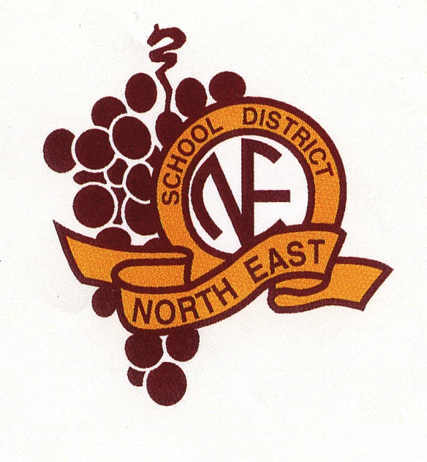

The mission of the North East School District is to challenge and empower all students to develop and achieve personal aspirations, pursue a love of learning, and be responsible citizens in a dynamic world.

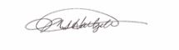
Equal Opportunity Employer

__________________________________
Dr. Michele S. Hartzell, Superintendent

